United States Naval Academy

Stewardship Report 2010 - 2011

The Naval Academy Annual Fund

The United States Naval Academy is home to both tradition and innovation, where concepts of duty, honor and leadership join with new ideas and the latest technology in the development of outstanding 21st-century military leaders. The Naval Academy Annual Fund serves as a resource to the Superintendent to address both familiar and emerging needs, going a step beyond government appropriations to achieve a true margin of excellence for the Brigade of Midshipmen.
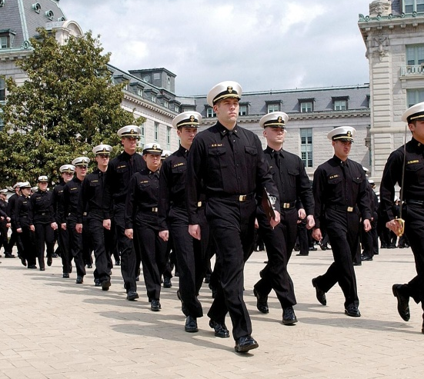

Plebe summer is a fixture of Naval Academy life, and for many years the Plebe Summer Book has introduced parents to the activities and training their sons and daughters experience. This annual publication – supported by the Annual Fund and a useful tool for the Office of Admissions – also provides background information on the Academy, its goals and traditions, and a statistical profile of the plebe class.

The Bancroft Lecture Series, named in honor of the founder of the Naval Academy, George Bancroft, and held in October – the month of his birth and of the founding of the Academy – is supported by the Annual Fund. For 31 years the lecture has brought distinguished historians to speak before the Brigade of Midshipmen. The October 2010 Bancroft Lecture – “Past Obsessions: World War Two in History and Memory” – was delivered by Dr. Carol Gluck, the George Sansom Professor of History at Columbia University, whose specialty is Japanese history from the mid-nineteenth century to the present.

And the Annual Fund supports athletic programs at the Naval Academy Preparatory School (NAPS), established almost 100 years ago to prepare selected candidates for the rigors of the Academy; provides a stipend to the USNA Alumni Association in support of Shipmate, career services, a robust website and more; and covers the full cost of fundraising at the USNA Foundation where millions of dollars in restricted support to the Academy are raised annually.

But the Annual Fund does not cater to tradition alone. Last year, the Superintendent chose to use the Annual Fund to support a new deputy director position in the Office of International Programs and to provide faculty for the growing Summer Science, Technology, Engineering and Math (STEM) Programs, now serving more than 375 students every year. In addition, VADM Miller made use of the Annual Fund to underwrite expenses of the successful first annual Naval Academy Science & Engineering Conference (NASEC), held in November 2010 on the topics of Information Technology, Transportation and disaster preparedness and featuring such speakers as The Honorable Shirley Ann Jackson, President of Rensselaer Polytechnic; ADM Thad Allen, USCG (Ret.); and CAPT Jim Lovell, Jr. USN (Ret.).

Over the past ten years, the Annual Fund has provided early support for several other successful programs, including the Stockdale Center for Ethical Leadership, faculty enrichment initiatives, and admission outreach. This is the power of the Annual Fund – unrestricted gifts that allow maximum flexibility. Deep appreciation is extended to all those who support this effort.

